DECEMBER, 2006 VOLUME 1, Issue 12

The Old Movie Maven

THE BATTLE OF THE SEXES;
Or, Is There Really Sex in the Cinema?

~~~

The Old Movie Maven (TOMM) is published once a month for
film lovers of classic movies and the actors, directors,
costume designers, make-up artist, cameramen
and the other people who never got enough
credit for all their hard work
over the years.

COMMENTS, QUESTIONS AND SUGGESTIONS ABOUT SUBSCRIPTIONS AND BACK ISSUES CAN BE SENT TO

Virginia Johnson
Publisher/Editor

P.O. Box 54493 theoldmoviemaven@yahoo.com Hurst, TX 76054 http://theoldmoviemaven.tripod.com

SUBSCSRIPTION:
One (1) Issue - $ 3.00
Sis (6) Months - $15.00
One (12) Year - $30.00
Back Issues - $ 3.50 @
See Page ???????

ALL MOVIES ARE AVAILABLE COMMERCIALLY OR ON YOUR
LOCAL CABLE CHANNELS UNLESS OTHERWISE NOTED.

<><><><><><><><><><><><><><><><><>

TABLE OF CONTENTS:

FROM MAVEN’S DESK: Sex in the Cinema 101 PAGE: 3

B-FEATURE: The Thin Man (1934) PAGE: 15

BACK ISSUES: PAGE: 17

CHILDREN’S CORNER: Shirley Temple PAGE: 6

FLASH: Powell/Loy Still? PAGE: 11

MAIN EVENT: Tarzan (1932) PAGE: 12

MAVEN’S SERIES: Star of Midnight (1935) PAGE: 7

PERSON OF THE MONTH: Carla Laemmle PAGE: 4

QUOTE OF THE MONTH: Walter Winchell PAGE: 4

SHORT SUBJECT: Charlie Chan PAGE: 11

UNIVERSAL MONSTERS GENEOLOGY
The Bride of Frankenstein (1935) PAGE: 8

WEBSITE OF THE MONTH:
www.crimelibrary.com PAGE: 4

<><><><><><><><><><><><><><><><><>


FROM MAVEN’S DESK: Sex in the Cinema 101

If you cannot get rid of the family skeleton, make it dance!
George Bernard Shaw

Back in the early days of movie-making in Hollywood, the studios frowned on actors even being married . . . forget about having children!

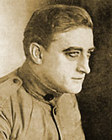
(Francis X. Bushman)

Francis X. Bushman, the first “King of the Movies” and star (as Messala) of Ben-Hur (1925) fell from grace and favor with the public (or at least the women in his audience) when they found out that he was making patty-cakes outside his marriage.
His career never did recover.
Of course, then we have cases like John Barrymore who married some four times. . . . He still managed to only have two children, Diana Barrymore and John Blythe Barrymore (Drew’s father).
He’s even supposed to have said, “I’m even thinking of taking a fourth wife. Why not? Solomon supposedly had a thousand wives and he’s generally considered to be a synonym for wisdom.”
But Hollywood, or at least Hollywood’s audiences across America, couldn’t handle sex on the screen, and had to call in outside forces in the guise of Will H. Hayes who headed the Hayes Office (Surprise!) from 1922 to 1945.
Audiences after 1945 were increasingly treated to scenes like Burt Lancaster and Deborah Kerr rolling on the beach with the ocean sweeping over them in From Here to Eternity (1953).
Now Maven can’t turn the TV on without having to choose between minute and intimate details of stars’ lives and everything in their movie roles from . . . well, all Lancaster and Kerr had to worry about was getting crabs in their beach scene in Eternity.
Not getting crabs that you have to go to the doctor about!
So think of this issue as Sex in the Cinema 101!

QUOTE OF THE MONTH: Walter Winchell

Sex can’t be important in films. Remember, the world’s leading film attractions remain Charlie Chan, Boris Karloff and Shirley Temple.

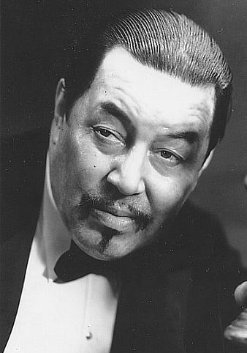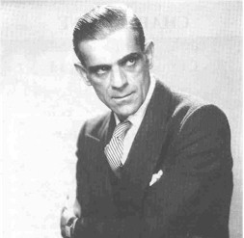
(Warner Oland as Charlie Chan, Boris Karloff and Shirley Temple)

WEBSITE OF THE MONTH: www.crimelibrary.com

This website has a wealth of information about all sorts of crimes: who dun what to whom . . . .
They do each crime up with as much information as is possible on each case, including pictures when available.
They have a whole section given over to celebrity crimes and that includes Hollywood habitués like Lana Turner whose screen personas just dripped with sex appeal.
So www.crimelibrary.com/notorius_murders/famous/lana_turner/2.html proves that there was sex in Hollywood . . . even if it wasn’t always on screen!
And if you’re like Maven, you’ll be going back for more!

PERSON OF THE MONTH: Carla Laemmle

Maven has gotten doubly lucky!
Ms. Carla Laemmle kindly wrote to Maven again about the coach scene in Lugosi’s version of Dracula:

As to “The Coach Scene”: there was no director for it. It was filmed on Universal’s back lot. They had several property men who would jiggle the coach back and forth to make it appear on very rough road [sic]. As the secretary to a prim English lady I was to read from a brochure—“Among the rugged peaks”—etc.—Evidently they didn’t consider it necessary to have a director for it.

Ms. Laemmle also is in the process of writing her autobiography, Carla Who?, that Maven hopes to let you know more about as she gets the details!
She also told me that her birthday is the same as Bela Lugosi’s was . . . October 21st and has recently traveled to the Laupheim Museum in German.
Complete with a personally-autographed photograph of her at the museum.
One elegant lady well worth knowing!

CHILDREN’S CORNER: Shirley Temple Black

Okay. Maven knows you’re wondering what Shirley Temple Black could possibly have to do with sex in the movies when she was a child actress.
So did she!
Mrs. Black wrote about it in her autobiography, Child Star [McGraw-Hill Publishing Company, New York, 1988, pages 128 to 129], when she made Captain January (1936):

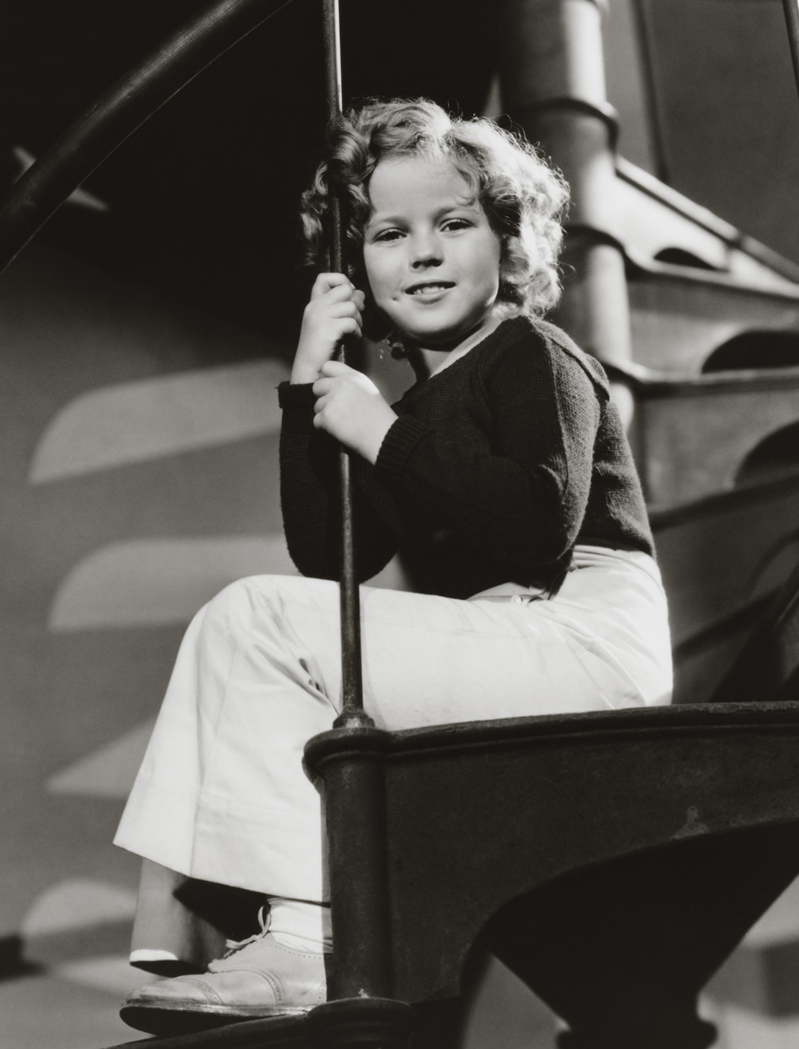
(Shirley Temple in Captain January [1936])

. . . As a companion to lonely lighthouse inspector Slim Summerville, there appeared a spindle-legged crane standing four feet tall. Costumed with a huge bow ribbon tied around the top of its towering neck, it was standing quietly when I came up from behind, reached to feel its tail feathers, and asked aloud, “Do you remember me?”
Swiveling its neck, the crane stretched its long silver of bill toward my face, tumbling me backwards in surprise.
“Why should the crane remember you?” asked Summerville, helping me up.
“A crane?” I asked. “I thought it was a stork.”
[She and a co-star had been in a trap behind a run-away stork in the Baby Burlesque days of their early careers.]
The bird did not seem to share my humor. Turning in a dainty circle it took a long step toward me, and naturally I dodged backwards out of reach.
“They always go for the eyes,” muttered Jonesy the propman. “Keep your distance.”
To resolve my problem—or was it the bird’s?—a propman tried stretching himself prone out of camera view, holding the bird’s feet stationery. He got pecked for his ingenuity, and wound up hammering flathead nails through the webbing of the crane’s feet, anchoring it to a floorboard.
Emphasizing that it was actually painless for the bird, the director pledged everyone to silence about the solution. It worked. We finished the shot, and someone wrenched out the nails with a claw hammer. The crane must have felt fine because in the next scene it danced an unconcerned jig to Summerville’s harmonica.
But somebody had snitched. Late that afternoon onto the set bustled an official from the local humane society. I heard no one admit what had happened, and certainly the crane made no complaint. The perforations in his feet were invisible from a distance, and each time the woman tried for a closer inspection, the crane pecked at her too. . . .

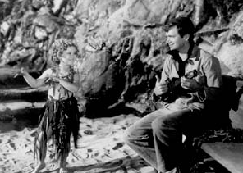
(Shirley’s hula with Buddy Ebsen)

Where everything really exploded was with my hula. As a nubile island maiden, I wore a hula skirt and brassiere of slippery seaweed fronds, and swayed and swished until my costume seemed alive. Whatever my sin of suggestiveness, reviewers from the Mothers Clubs of America gasped in Horror. The hula was immoral.
No studio wants to fly in the face of that sort of charge. The scene was rewritten, the hula deleted, and I was refilmed dressed this time in tight-fitting trousers with flared bottoms, doing a sailor’s hornpipe.

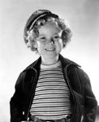
(Shirley Temple in sailor togs)

You can’t please everyone. Writing for the The London Spectator, in his August 7, 1936, review, film critic Graham Greene characterized Captain January as “. . . a little depraved, with an appeal interestingly decadent. . . . Shirley Temple acts and dances with immense vigor and assurance, but some of her popularity seems to rest on a coquetry quite as mature as Miss [Claudette] Colbert’s and on an oddly precocious body, as voluptuous in grey flannel trousers as Miss Dietrich’s.”

Now, Little Shirley would be in some rehabilitation center for drugs and/or alcohol by the time she was twelve and Maven doesn’t even want to think of the scripts she would have been offered as she grew up today!

MAVEN’S SERIES: Star of Midnight (1935)

Star of Midnight isn’t really part of any series but it is very much like the many that William Powell did . . . like Philo Vance and The Thin Man. So you might want to add it to your William Powell section of videos!
What does Star of Midnight have to do with sex in the cinema?

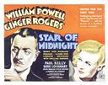

There’s a running gag between Powell as Clay “Dal” Dalzell and Ginger Rogers as Donna Mantin about their getting married—she wants to and he’s confronted with his “history” with other ladies!—and one or two scenes where she stays overnight in his apartment.
That wasn’t done years later when Maven was growing up!
But they’re “sleuthing”—not “messing around”!
At least not until . . . .
Never mind!
It’s a great mystery with a trick: The Star of Midnight is both the name of the movie and the actress starring as the star of Midnight.
This is one of the early movies Ginger Rogers made without Fred Astaire

UNIVERSAL MONSTERS GENEOLOGY:
The Bride of Frankenstein (1931 –
And a glance back at Dracula)

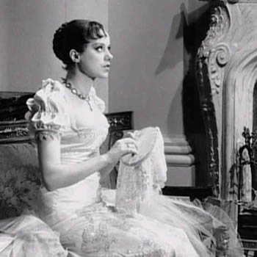
(Elsa Lanchester as Mary Shelley)

The Bride of Frankenstein was the first off-shoot of our first two Monster Classics, Dracula and Frankenstein.
Ironically, though, Bride does have an equivalent in Dracula: Dracula’s three wives are seen in both the English and Spanish versions.
But do we get three times the amount of sex?
Are you kidding?
What’s three times zip?
The closest we get to sex in Bride is in the prologue with Gavin Gordon as Lord Byron and Douglas Walton as Percy Shelly to Elsa Lanchester’s Mary Shelley.

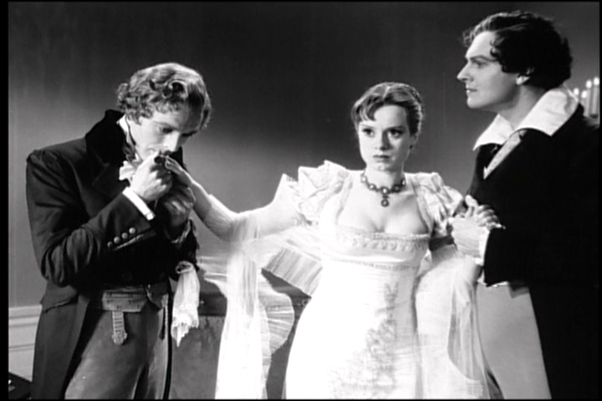
(L. to r., Douglas Walton, Elsa Lanchester, Gavin Gordon)

Although, come to think of it, Maven might consider a ménage a trios with the two of them if it got her out of all those clothes!
Of course, this outfit isn’t as bad as what she had to wear later as the Monster’s Mate with Colin Clive as Frankenstein, Boris Karloff as the Monster and Ernest Theisger as Dr. Pretorious.

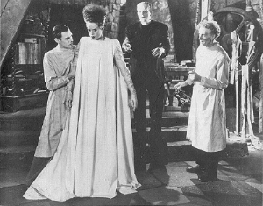
(L. to r., Colin Clive, Elsa Lanchester, Boris Karloff and Ernest Theisger)

On the other hand, Dracula’s wives had those long dresses to trip over as they traipsed through his castle that was filled with cobwebs, spiders and Texas armadillos in the Lugosi version of Dracula.

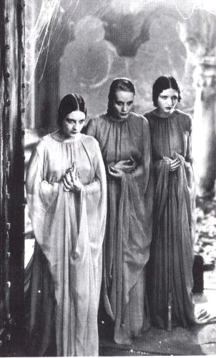
(L. to r., Dorothy Tree, Geraldine Dvorak, and Cornelia
Faw [real name: Mildred Pierce!] as Dracula’s wives)

That’s something else that has bothered Maven . . . how did they ever get Texas armadillos in the Carpathian mountain castle in 1930?
Did they have some kind of foreign exchange program going and got our armadillos?!
Vampire bats, maybe . . . ?
But let’s leave Texas politics out of it!
But what Bride lacked in quantity, Bride made up for in quantity of time!
You still don’t see any sex but you have Elsa Lanchester in the prologue and the finale plus the first—and only—pitter-patter of little feet in all of Universal Studio’s Classic Horror Movies:

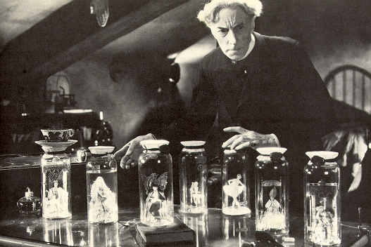
(Ernest Theisger with his made-from-scratch “Little People”—Joan Woodbury is the Queen on the left and Charles Laughton as the King on the right—a recipe
that not even Martha Stewart, the Diva of Domesticity, can whip up!)

The closest thing to sex in Bride is Valerie Hobson as a brunette Elizabeth running around Frankenstein’s bedroom in a negligee . . . and perhaps not even then in their off-screen scenes, depending on how far he is on the road to recovery from Frankenstein!
Eventually, they did what they can and end up with The Son of Frankenstein, made only three years later in 1939.
Only three years later . . . hmmm.
Either somebody neglected to tell them about just how long the birds and the bees take to do this sort of thing or it just takes longer to get through the studio system in Hollywood!
All well and good but Sonny-Boy turns out to have been living out of the country and returning as a middle-aged family man, even if he does look like Basil Rathbone!
But Maven wonders . . . Dracula had three wives so when did he did indulge in “hanky-panky” with them when he was so busy trying to build up his own, shall we say, blood bank”!
Did he have any offshoots lurking about in the shadows that we ought to know about?!
Or was that what we got in exchange for those armadillos?!
To find out . . . stay tuned on this same bat time on this same bat channel!

Dracula (1931) Frankenstein (1931)
| |
? The Bride of Frankenstein (1935)

FLASH:
“Good evening, Mr. and Mrs. America, from boarder to boarder,
coast to coast and all the ships at sea, let’s go to press . . . . “
[Walter Winchell]

Powell/Loy Still?

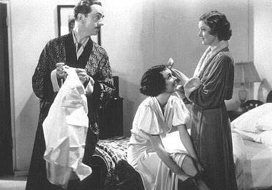

Maven wonders about this picture. . . . William Powell and Myrna Loy are the actors standing but who’s sitting on the bed?
She looks like she might be Maureen O’Sullivan but even Maven can’t be sure so please let Maven know at theoldmoviemaven@yahoo.com if you recognize the actress and/or movie!

SHORT SUBJECT: Charlie Chan

You know there had to be sex somewhere when you watch the Chinese detective Charlie Chan in the movies!
How many children he had depended upon the movie you were watching . . . and you can check out http://charliechanfamily.tripod.com/id66.html , Rush Glick’s excellent website, if you don’t believe me!

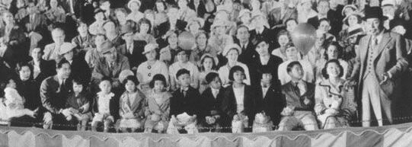
(Charlie Chan at the Circus [1936]: Warner Oland and family.)

You can see that Mr. and Mrs. Chan took their whole family of twelve children to the circus with them!

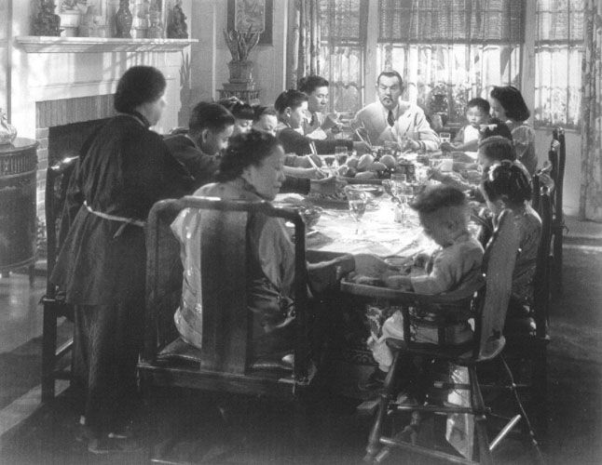
(Charlie Chan in Honolulu [1938] with Sidney Toler at
the head of the table with the rest of the family)

There are only eleven children at the table with Mr. and Mrs. Chan but # 1 son, Lee, is in New York at art school and # 2 daughter, Ling Rose, is having # 1 Chan grandchild!
So somebody is staying busy in Hollywood!

THE MAIN EVENT: Tarzan (1932)

Yes, Virginia, there really is sex in Hollywood!
But when we do see it in the classic movies of Way Back When in Hollywood, it was by innuendo and symbolism . . . keeping the details where many thought they belonged: on the streets, in the pool halls and in the backseats of roadsters—and we have Will Hays to thank for it!
Hollywood decided to clean up their act and hired Hays to head “The Hays Office”—officially The Motion Picture Production Code of 1930*.
It was several pages of “Thou Shalts” and “Thou Shalt Nots” of rules to make the movie industry more palatable after such scandals as Fatty Arbuckle’s alleged rape of Virginia Rappe and the still officially unsolved murder of Director William Desmond Taylor.
Plus Cecil B. de Mille could make movies in the twenties where people could carry on any way they wanted as long as the wrong-doers got their just rewards at the end of the movies.
Then the Hays Code came into effect.
Section II. Sex says:

The sanctity of the institution of marriage and the home shall be upheld. . . .

1. Adultery, sometimes necessary plot material, must not be explicitly treated, or justified, or presented attractively.
Even living in the jungle, Tarzan and Jane had to get married or their premarital sex probably would have come under this section!

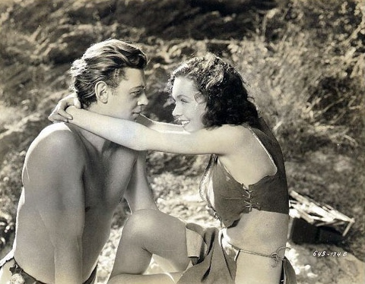

2. Scenes of Passion

- They should not be introduced when not essential to the plot.

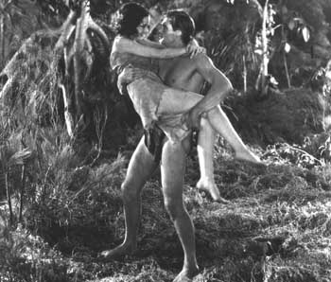
And we can’t have that, can we?!

b. Excessive and lustful kissing, lustful embraces, suggestive postures and gestures, are not to be shown.
Of course not. What do you think Tarzan and Cheeta were doing befo . . . never mind!

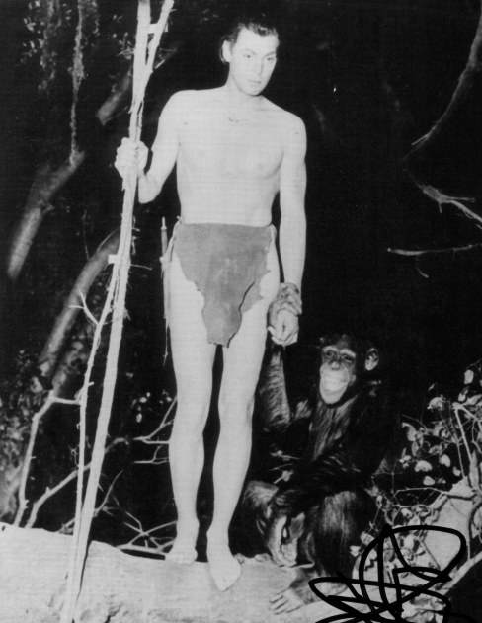

- In general passion should so be treated that these scenes do not stimulate the lower and baser element.
We couldn’t have just anybody playing with Cheeta! . . .

VI. Costume

1. Complete nudity is never permitted. This includes nudity in fact or in silhouette, or any lecherous or licentious notice thereof by other characters in the picture. . . .
Would the movie-makers of today be hauled up short with this stuff!

3. Indecent or undue exposure is forbidden.
There is no indecent or undue exposure today! You can see less than this at swimming pools, if not the streets and malls!

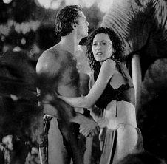

So what happens if the couple is married from the get-go?!

For that we turn to . . . .

THE B-FEATURE: The Thin Man (1934)

Now take The Thin Man (1934), made from Dashiell Hammett’s book.

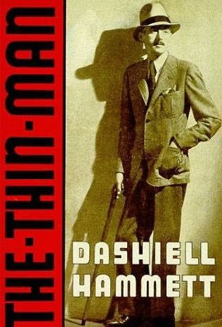

W.S. Van Dyke was the director of this Metro-Goldwyn-Mayer film, although M-G-M didn’t put much stock in it since they felt that Myrna Loy was too exotic and William Powell too old for their parts.
Now we know how perfect they were as Nick and Nora Charles.

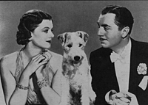
(Myrna Loy, Asta and William Powell)

Hammett imbued the most sophisticated couple in Hollywood history with elegance, style, wit and alcohol.

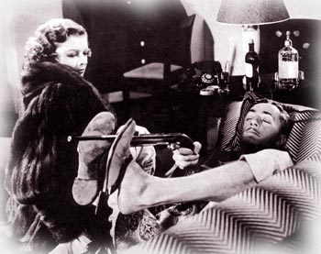
(The Thin Man makes a perfect Christmas movie for mystery lovers!)

Drinking alcohol was considered chic in the sophisticated playgrounds of New York of the thirties that Hammett frequented and was carried over in the other Thin Man movies to varying degrees.
We fortunately see the Charles in such homey scenes as raiding the icebox at midnight!

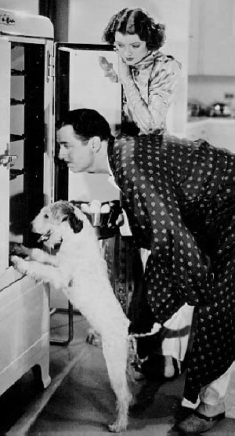
(The Charles Family on a midnight foray from After the
Thin Man [1936] and great to watch on New Year’s Eve!)

They do appear at bedtime but . . . how do you accomplish anything when you’re in separate twin beds?!

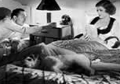
(The Charles Family at bedtime)

But . . . at the end of The Thin Man, they are on the train to San Francisco similar to this one:


(Accommodations for two with
only the lower bed made up.)

Nick puts Asta up in the upper bunk as the movie fades out at the end . . .
No X-rated scenes, no nudity, no nothing.
So how do we know anything happened?

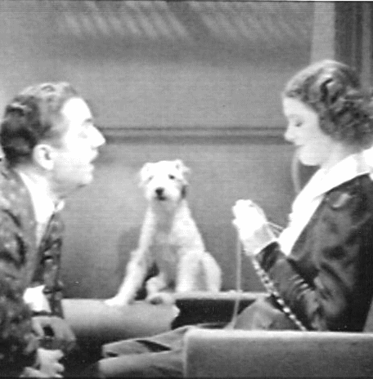

We have the scene at the end of After the Thin Man (1936) in another train when Nick Charles discovers that Nora is knitting a baby bootie . . . and then he realizes that there is . . . SEX in HOLLYWOOD!

*Maven pulled The Code up at www.artsreformation.com/a001/hays-code.html.

BACK ISSUES: Of The Old Movie Maven (aka TOMM)

Back issues of The Old Movie Maven are $3.50 each,
and make your check or money order payable to:

Virginia Johnson
The Old Movie Maven
P.O. Box 54493
Hurst, TX 76054

VOLUME 1 – Issue 1: Donnie Dunagan, James Arness and Peter Graves, Want-Ads, and Film Noir.

VOLUME 1 – Issue 2: Happy Valentine’s Day!, www.clarkgable.com, Olivia de Haviland and Joan Fontaine, Want-Ads, and Romantic Movies.

VOLUME 1 – Issue 3: GOING BATTIE WITH VINNIE: Or, The Price Is Right!, www.vincentprice.com, Charlie Chan on Broadway, Lady Sleuths in the Movies, Eve Arden, The Innes-Brown House, The Bat (1959) and The Invisible Man Returns (1940).

VOLUME 1 – Issue 4: Mae West, http://charliechanfamily.tripod.com, Blondes at the Movies, Charlie Chan Chat Room, Rush Glick, Psycho (1960), Want-Ads.

VOLUME 1 – Issue 5: GIRLS! GIRLS! GIRLS! Or, Do Blondes Really Have More Fun?, Dorothy Parker; www.charliechan.net; Kurt Schmidt, Nancy Drew; Shirley Temple and Orson Welles; Jean Harlow and Paul Bern; The Paul Bern House; Colleen Moore and Mary Astor; Colleen Moore’s Doll House.

VOLUME 1 – Issue 6: A FAMILY AFFAIR; Or, Who’s Your Daddy?; John Barrymore; www.lonchaney.com; Charlie Chan; Perry Mason; Happy Mother’s Day!; The First Face Transplant; A Marriage Made . . . Only in Hollywood?, House of Dracula; The Quiet Man; Lon Chaney, Father and Son; Guess Who?; Want-Ads; Back Issues.

VOLUME 1 – Issue 7: WHODUNIT; Or, Brother, Can You Spare a Joke?; Bob Hope; www.imdb.com; Ernest Morrison; Dead End Kids/East Side Kids/Bowery Boys*; Haunted Spooks ; The Cat and the Canary (1927) and (1939) and The Ghost Breakers; FLASH: Harold Lloyd; Mickey Rooney and Ava Gardner; Charlie Chan in Egypt (1934); The Smiling Ghost.

VOLUME 1 – Issue 8: WHOZAT; Or, Character Actors . . . from A to Z; Character Actors; Let’s Get Started; Let’s Get Started (Who Did What In Which); Whozat? Cartoon.

